**Confirming SQL Server Connectivity**

You simply can right-click on the desktop and select New – Text Document to create an empty text file. Then, you need to right-click on the file and select Rename, and change the file extension from .txt to .udl to create an empty Microsoft Data Link file. If you don’t see any file extensions on your files, you can go into Folder and Search options in Windows Explorer and disable the option to hide file extensions.

After you have created a Microsoft Data Link File, simply double-click on it to open up the Data Link Properties dialog as shown in Figure 3.

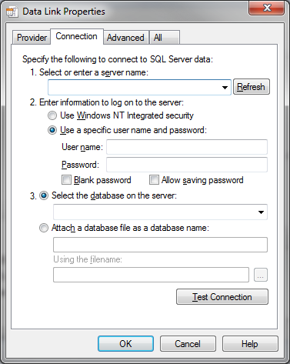

Figure 3: Data Link Properties – Connection Tab

For some reason known only to Microsoft, this dialog always opens on the Connection tab (as shown in Figure 3), but you actually need to click on the Provider tab to get to what you see in Figure 4.



Figure 4: Data Link Properties – Provider Tab

Depending on what OLE DB Providers are installed on the machine that you want to test, you may see a different list than what is shown in Figure 4. For this test, you should select the Microsoft OLE DB Provider for SQL Server, and then go back to the Connection tab. You need to enter a server name (or IP address), and then a set of valid credentials with either Windows NT Integrated security (which will use your Windows credentials) or a User name and password using SQL Server authentication as you see in Figure 5.

Figure 5: Data Link Properties – Provider Tab with Connection Information

After you have done this, you should be able to select a database on the server and then click on the Test Connection button to make a connection to that database on that server. If all is well, you should be rewarded by the success dialog as shown in Figure 6.

Figure 6: Microsoft Data Link – Test connection succeeded dialog

This quick, simple test lets you confirm that the remote machine you tested can connect to the SQL Server instance and database. It proves that the SQL Server service is running and has an appropriate network protocol enabled. It also proves that you have network connectivity that is not being blocked by a firewall and that the credentials that you used have rights to connect to the instance and database. This quick technique is very useful for verifying connectivity and basic functionality from any machine, whether or not it has SQL Server Management Studio or any other development tools installed.